Leaching kinetics of rare earth elements from wasted fluorescent powder

Vinh Hung Ha*¹⁾, Trung Hai Huynh ¹⁾, Minh Trang Vu¹⁾, Huy Viet Le¹⁾, Duc Quang Nguyen¹⁾, Nhat Quang Nguyen¹⁾
¹⁾ School of Environmental Science and Technology, Hanoi University of Science and Technology (HUST), 1 – Dai Co Viet, Hanoi, Vietnam
* Corresponding author’s email address: hung.havinh@hust.edu.vn
Keywords: rare earth elements; leaching kinetics; recovery; fluorescent powder;
Introduction
Concentrations of rare earth elements (REEs) which are mainly in fluorescent as yttrium, europium, cerium and terbium, are very valuable materials and widely used in the field of high technology such as nuclear reactors, laser, super conductors and others aspects of life due to its optical, electrical, and magnetic characteristics (Ochsenkuhn-Petropulu et al., 1996; Park et al., 2012). Thus, demand for REEs has been rapidly increasing recently, the leader of the world market, has been tightening restrictions on exports of REEs. Therefore, recovery of REEs from waste is necessary in order to supplement the depleting natural resources and also to promote the recycling for recovery of other valuable materials.
The hydrometallurgy is an effective technology for the leaching of rare earths from low-grade metal resources due to selective leaching by appropriate solvents, low process cost and relatively low pollutant generation (Chul-Joo Kim et al., 2014). In this work, the leaching kinetics of REEs from waste fluorescent powder has been studied under the conditions of laboratory using the response surface methodology and the results are presented and discussed below.
Material and Methods
Waste fluorescent powder used in this study was separated from waste fluorescent lamps using ultra-sonic wave technology. The inductively coupled plasma mass spectrometry (ICP-MS) analysis showed that Y and Eu were 0.95 wt% and 0.08 wt%, respectively. Before leaching, the samples were treated by alkaline fusion with NaOH at 0.35 ratio of NaOH/powders for 2 hours at 950ºC in order to transform the REE phosphors in oxides.
The leaching tests were carried out in bottle glasses with close caps in fix conditions of 10% solid/liquid ratio and 150 rpm shaking in 50 ml solution volume. The factors investigated were HCl concentration (2.5−3.5 M), temperature (30−50 ºC) and time (30−50 min). Table 1 shows the experimental conditions of this full factorial design with experimental runs of 8 at factorial and 3 replications at the centre (Box and Hunter, 1957). The concentrations of Y and Eu in leaching solutions were determined by ICP-MS. In each test, the final residue was dried and leached by aqua regia to analyze REEs.

Results and Conclusions
The results of 11 leaching runs are given in Table 2. Results showed that the yields of Y are in the range of 69.8% to approximate 100%. The yields of Eu are from 75.4 % to 99.9%. By the MODDE 5.0 software, predicted equation for the concentration of Y and Eu is shown in Eq. (1) and (2).
Y_{(Y)} = 5.674 + 0.219.X₁ + 0.242.X₂ + 0.386.X₃ + 0.0680.X₁.X₂ + 0.105.X₁X₃ + 0.195.X₂.X₃ (1)
y_{(Eu)} = 0.290 + 0.007.X₁ + 0.011.X₂ + 0.014.X₃ + 0.003.X₁X₃ + 0.008.X₂.X₃ (2)
Reaction kinetics
At constant HCl concentration, the general form of the rate equation for reaction can be expressed as:
dC_{i}/dt = k₁.C_{i}^{α} (3)
The pseudo-ﬁrst order was used to ﬁt the experimental data, Eq. (3) become dC_{i}/C_{i}= k₁.dt. Integrating and applying the boundary conditions, equation takes the form:
ln(C_{t}/C₀) = k₁.t - k₁.t₀ (4)
Fig. 1 show the plots of ln(C_{t}/C₀) against time, t. Here, C₀ and C_{t} denote concentration of Y (and Eu) at time t=12 min and t>12 min. It can be seen that good linear relationships are obtained at all HCl concentration investigated. All the straight lines pass through the origin and no diversion of the lines from linearity is observed even at the end of the reaction. It is therefore evident that in HCl acid solutions, Y and Eu leaching reaction kinetics is first order with respect to Y and Eu, i.e. α =1. The pseudo-first order rate constants, k₁, can then be calculated from the slopes of the straight lines, and the results are listed in Table 3, in which the average value of k₁ are 0.0095 and 0.0060 (h⁻¹).
In order to study the effect of temperature on REEs leaching, reaction conditions at HCl 3M and various temperatures were investigated. Again, the ln(C_{t}/C₀) vs. t plots show straight lines for all temperatures over the range of 30–50 ºC. The calculated k₁ values, presented in Table 3, are used to generate the Arrhenius plot (Fig. 2) and the activation energy of Y and Eu leaching which is determined from the slopes and the Arrhenius equation are 36.60 and 38.68 kJ/ mol, respectively.

Acknowledgements
The authors wish to acknowledge Ministry of Education and Training of Vietnam for financially supporting under project entitled "Studying on Yttrium and Europium recovery technology in waste fluorescent lamps – Code: B2017-BKA-43".
References
Box, G. E. P., Hunter, W. G. (1957), Multi-factor experimental design for exploring response surfaces. J. Math. Stat. 28, 195−241.
Kim Chul-Joo, Yoon Ho-Sung, Chung Kyung Woo, Lee Jin-Young, Kim Sung-Don, Shin Shun Myung, Lee Su-Jeong, Joe A-Ram, Lee Se-Il, Yoo Seung-Joon, Kim Seung-Hoon (2014), Leaching kinetics of lanthanum in sulfuric acid from rare earth element (REE) slag. Hydrometallurgy 146, 133–137.
Ochsenkuhn-Petropulu, M., Lyberopulu, T., Ochsenkuhn, K.M., Parissakis, G. (1996), Recovery of lanthanides and yttrium from red mud by selective leaching. Anal. Chim. Acta. 319, 249–254.
Park, H.K., Lee, J.Y., Cho, S.W., Kim, J.S. (2012), Overview on the technologies for extraction of rare earth metals. J. Korean Inst. Resour. Recycl. 21 (3), 74–83.
Table 1. Independent variables and their corresponding levels
Independent variable | Symbol coded | Coded variable levels
Independent variable | Symbol coded | −1 | 0 | 1
Time (min) | X₁ | 12 | 16 | 20
HCl concentration (M) | X₂ | 2.5 | 3 | 3.5
Temperature (^{O}C) | X₃ | 30 | 40 | 50

Table 2. Central composite rotatable design arrangement and results
Run | Independent variable |  |  | Y conc.  (mmol/L) | Y yields, % | Eu conc.  (mmol/L) | Eu yields, %
Run | Time (min) | HCl conc. (M) | Temp. (ºC)
N1 | 12 | 2.5 | 30 | 4.973 | 69.8 | 0.441 | 75.4
N2 | 20 | 2.5 | 30 | 5.281 | 74.2 | 0.474 | 81.0
N3 | 12 | 3.5 | 30 | 5.108 | 71.7 | 0.471 | 80.5
N4 | 20 | 3.5 | 30 | 5.256 | 73.8 | 0.463 | 79.1
N5 | 12 | 2.5 | 50 | 5.338 | 75.0 | 0.468 | 80.1
N6 | 20 | 2.5 | 50 | 5.671 | 79.6 | 0.487 | 83.3
N7 | 12 | 3.5 | 50 | 5.947 | 83.5 | 0.519 | 88.8
N8 | 20 | 3.5 | 50 | 7.120 | ≈100 | 0.584 | 99.9
N9 | 16 | 3 | 40 | 5.887 | 82.7 | 0.512 | 87.5
N10 | 16 | 3 | 40 | 6.013 | 84.4 | 0.524 | 89.6
N11 | 16 | 3 | 40 | 5.828 | 81.9 | 0.515 | 88.0

Table 3. Rate constants for the REEs leaching reaction in 3M HCl at various temperature
T, ºC | 30 | 35 | 40 | 45 | 50
k of Y leaching (h⁻¹) | 0.0054 | 0.0076 | 0.0097 | 0.0116 | 0.0134
k of Y leaching (h⁻¹) | Average: 0.0095
k of Eu leaching (h⁻¹) | 0.0033 | 0.0047 | 0.0061 | 0.0074 | 0.0086
k of Eu leaching (h⁻¹) | Average: 0.0060

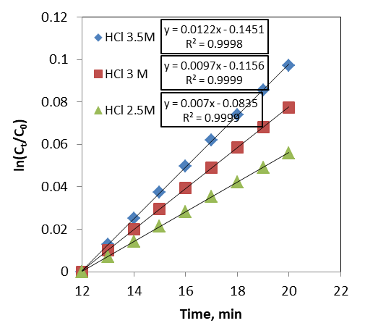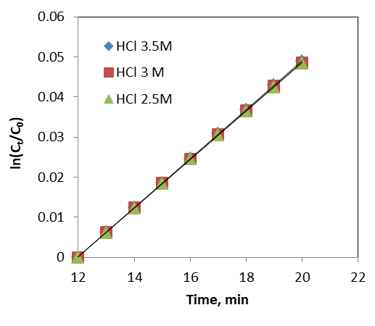
a) b)
Fig. 1 Pseudo first order plots for (a)Y and (b)Eu at 40ºC and various HCl acid concentration

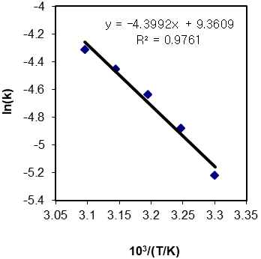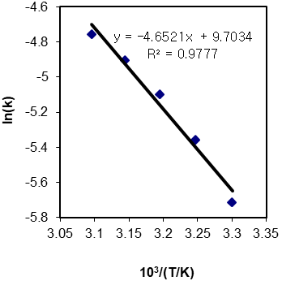
a) b)
Fig. 2 Arrhenius plot based on rate constants (a) for Y and (b) for Eu

